



**Experiment No. 04**

**Title: OpenStack Instance**

**Batch: B–1 Roll No.: 16010422234 Experiment No.: 04**

**_____________________________________________________________________________**

**Aim:** Launch an instance on OpenStack (IaaS)

**_____________________________________________________________________________**

**Resources needed:** OpenStack

**_____________________________________________________________________________**

**Prerequisite:** Knowledge of Client Server communication

**_____________________________________________________________________________**

**Theory:**

**_____________________________________________________________________________**

**Procedure:**

1. **Create an Instance**
2. **Assign and Attach Floating IP**
3. **Connect to the instance**

**_____________________________________________________________________________**

**Result: (All steps with screenshots)**

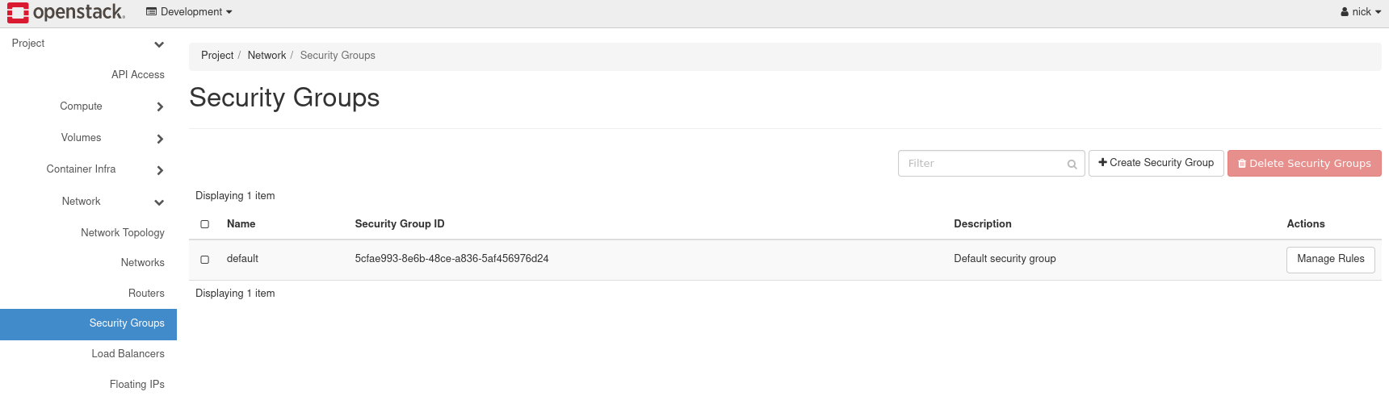

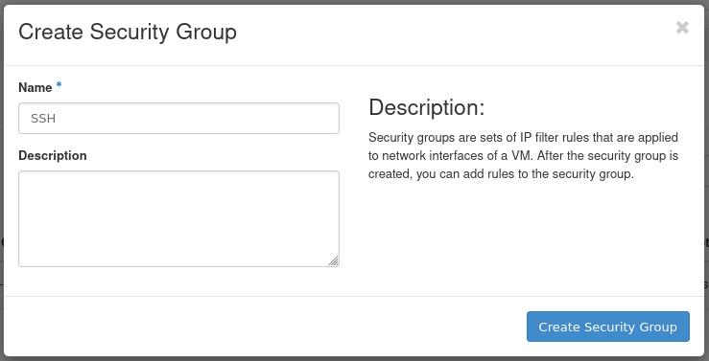

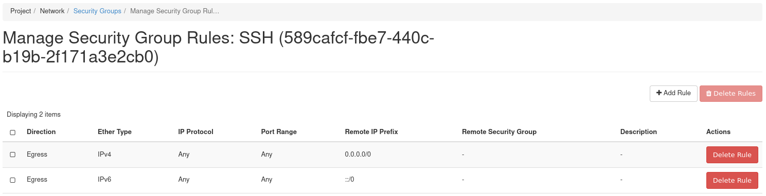

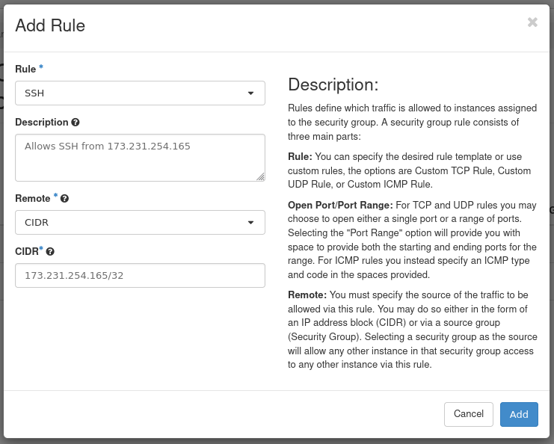

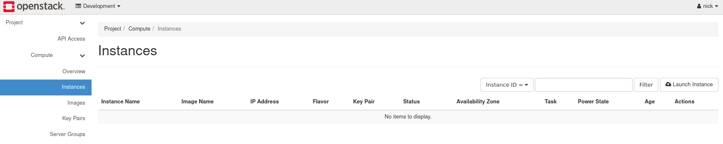

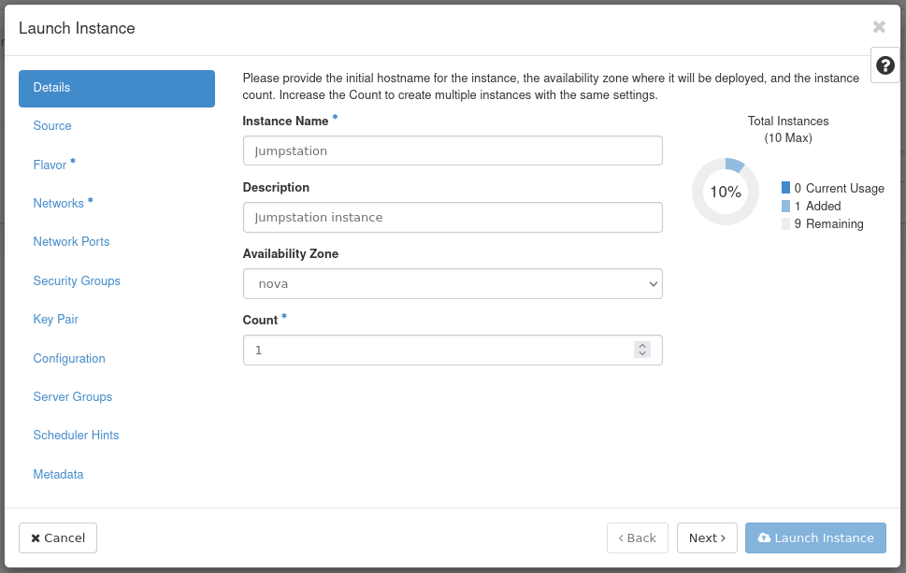

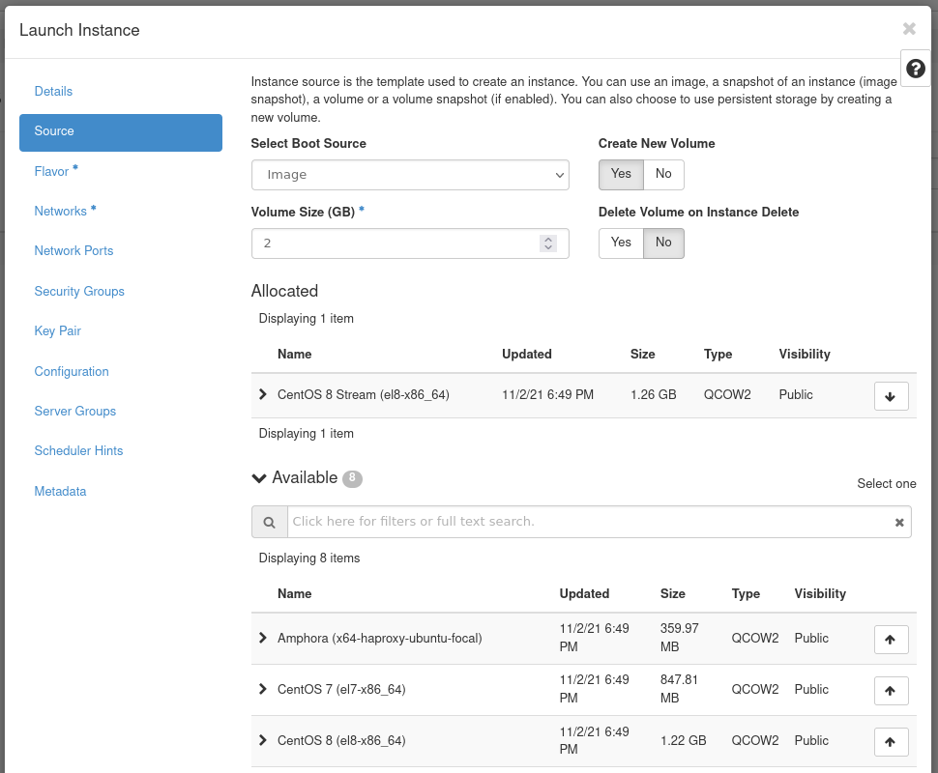

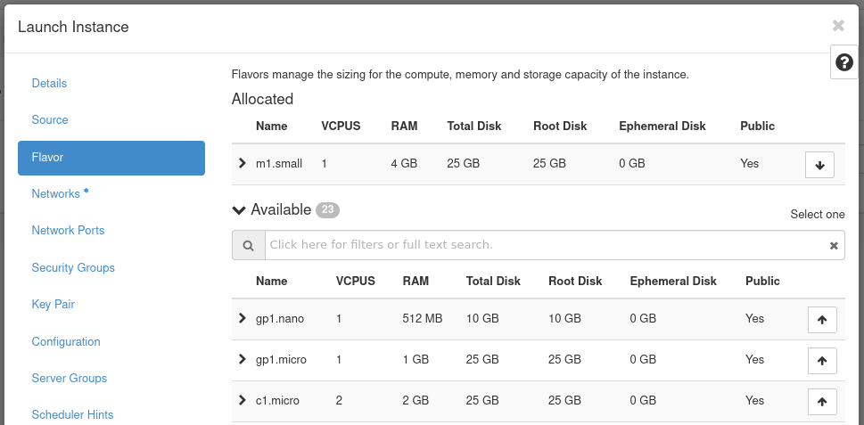

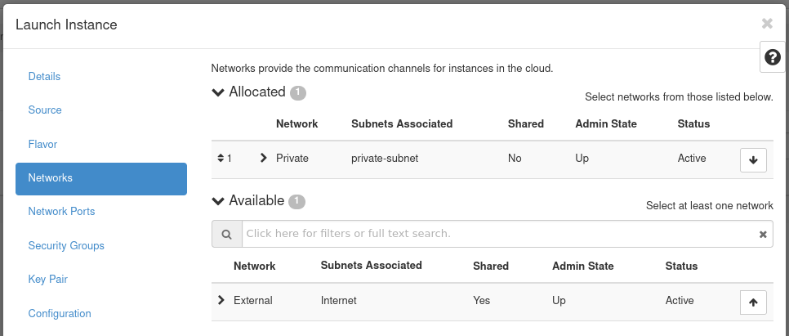

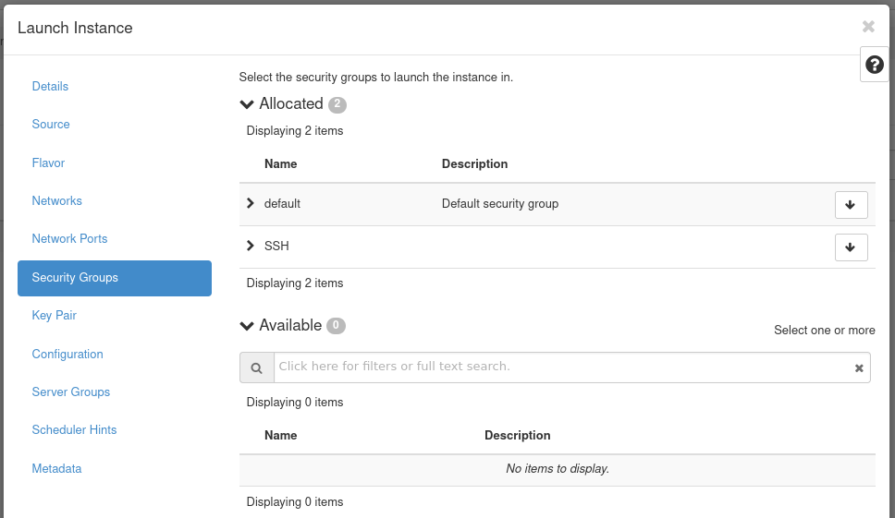

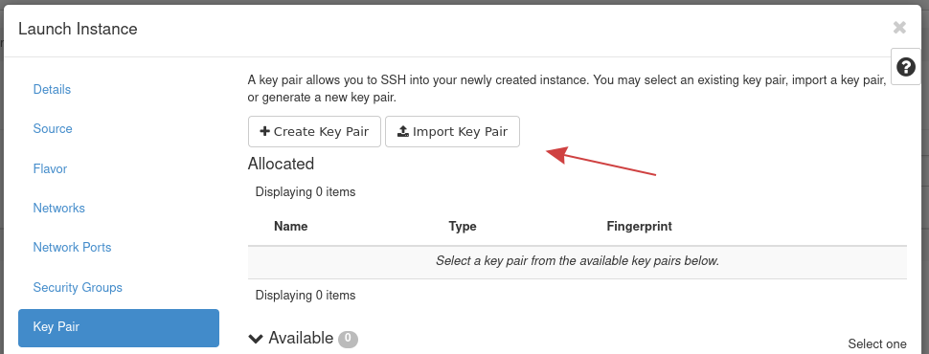

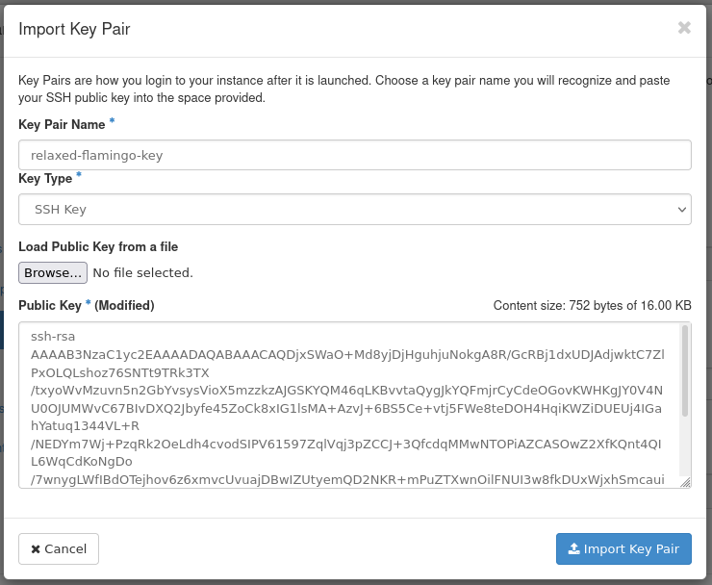



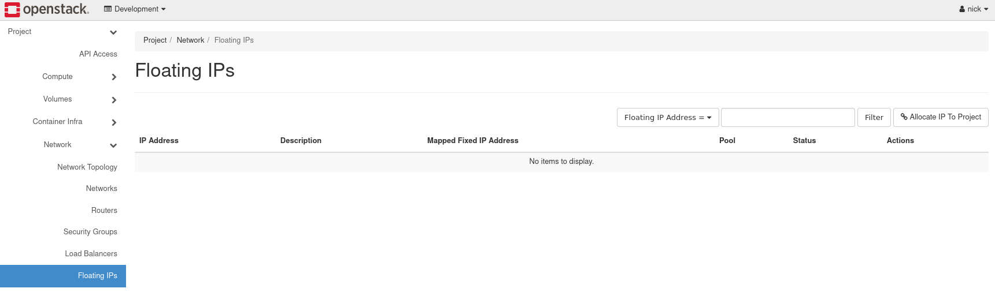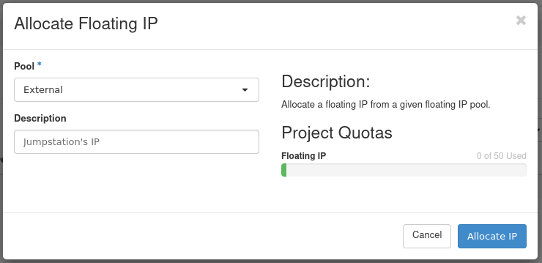



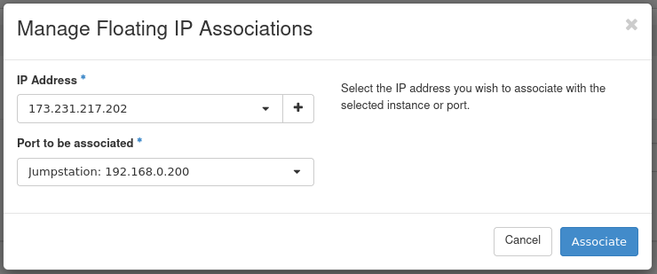

**_____________________________________________________________________________**

**Questions:**

1. **Compare OpenStack with Eucalyptus and Nimbus.**

**OpenStack:**

* Open-source cloud platform that enables users to create and manage both public and private clouds.
* Offers a variety of services such as compute (Nova), storage (Cinder), and networking (Neutron).
* Supports virtual machine and container orchestration.
* Highly flexible and customizable for organizations with specific cloud infrastructure needs.
* Offers strong community support and is widely adopted by large cloud providers and private data centers.

**Eucalyptus:**

* Another open-source cloud platform similar to OpenStack, but it is primarily designed for private cloud environments.
* Eucalyptus supports Amazon Web Services (AWS)-compatible APIs, which makes it easier for organizations to migrate workloads between AWS and private clouds.
* It has been mainly focused on IaaS offerings and includes compute, storage, and network management features.
* Unlike OpenStack, it does not have as many services or extensions for container management and other advanced cloud features.
* Eucalyptus is less popular in comparison to OpenStack and has a more limited ecosystem.

**Nimbus:**

* A cloud infrastructure platform primarily designed for scientific computing and academic purposes.
* Offers IaaS functionality, similar to OpenStack, but it’s more focused on the scientific community with support for high-performance computing (HPC).
* Nimbus is less customizable compared to OpenStack and lacks the broader enterprise cloud features found in OpenStack or Eucalyptus.
* Unlike OpenStack, Nimbus is not as widely adopted and has a smaller ecosystem of contributors.

**Comparison Summary:**

* **Flexibility and Community Support:** OpenStack offers more flexibility, a larger ecosystem, and better community support compared to Eucalyptus and Nimbus.
* **Usage Focus:** Eucalyptus is more AWS-focused, and Nimbus is tailored for academic/scientific use. OpenStack, however, provides broader cloud services for enterprise and public cloud environments.
* **Feature Set:** OpenStack provides a richer feature set than both Eucalyptus and Nimbus, especially with container orchestration, Kubernetes, and enhanced networking options.

1. **Compare OpenStack, OpenMetal and OpenShift.**

**OpenStack:**

* An open-source platform designed for building and managing cloud infrastructure (IaaS). It is highly customizable and widely used by public and private cloud providers.
* Focuses on virtualized resources, including compute, storage, and networking, providing a foundation for managing large-scale cloud environments.
* It can be extended to support container orchestration, but it is primarily a virtual machine-based cloud platform.

**OpenMetal:**

* A cloud platform that combines bare-metal servers and OpenStack functionality, offering a hybrid approach to cloud computing.
* Focuses on providing dedicated hardware resources with the scalability of a cloud infrastructure. OpenMetal allows for more customization and higher performance than traditional virtualized solutions.
* Typically used in industries where high performance, low latency, and specialized hardware requirements are needed.

**OpenShift:**

* An open-source container orchestration platform built on top of Kubernetes, designed to automate the deployment, scaling, and management of containerized applications.
* While OpenStack and OpenMetal focus on infrastructure (IaaS), OpenShift is a platform-as-a-service (PaaS) designed specifically for deploying and managing applications.
* OpenShift offers integrated CI/CD tools and has a strong emphasis on managing containerized workloads, which makes it ideal for microservices architectures.

**Comparison Summary:**

* **Focus:** OpenStack and OpenMetal are more focused on providing infrastructure (IaaS), while OpenShift is designed to simplify the management and deployment of containerized applications (PaaS).
* **Deployment:** OpenStack can be used to manage virtualized machines, OpenMetal provides bare-metal infrastructure with cloud features, and OpenShift enables container orchestration on top of Kubernetes.
* **Use Cases:** OpenStack and OpenMetal are suitable for creating custom cloud infrastructures, whereas OpenShift is ideal for cloud-native applications, particularly in containerized environments.

**_____________________________________________________________________________**

**Outcomes: CO3 — Analyze different cloud architectures and IOT cloud**

**_____________________________________________________________________________**

**Conclusion: (Conclusion to be based on the objectives and outcomes achieved)**

In this experiment, we successfully launched an instance on OpenStack and performed key tasks such as assigning and attaching a floating IP, followed by connecting to the instance using SSH. Through these activities, we gained practical experience in managing cloud instances on OpenStack, understanding the basic functionalities of OpenStack's IaaS (Infrastructure as a Service). This exercise also reinforced our knowledge of cloud infrastructure, instance management, and networking concepts, which are essential in modern cloud environments. The hands-on nature of the experiment provided a solid foundation for working with OpenStack and cloud technologies.

**_____________________________________________________________________________**

**Grade: AA / AB / BB / BC / CC / CD / DD**

**Signature of faculty in-charge with date**

**_____________________________________________________________________________**

**References:**

1. Create a User and Project in OpenStack Horizon

<https://openmetal.io/docs/manuals/operators-manual/day-1/horizon/create-user-project>

2. Connecting to an Instance using the OpenStack Console

<https://carleton.ca/scs/2024/connecting-to-an-instance-using-the-openstack-console/>

**_____________________________________________________________________________**